FRIENDS AND FAMILY TEST
Results for August 2023
Thank you to all the patients who completed a friends and family test survey in August 2023.

1) How likely are you to recommend our practice to family and friends if they needed similar care or treatment?
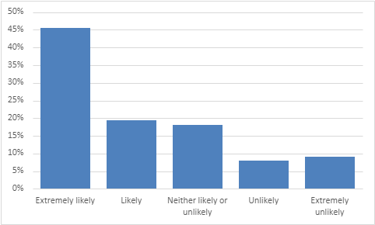
45% are extremely likely to recommend the practice
19% are likely to recommend the practice
18% are neither likely nor unlikely to recommend the practice
8% are unlikely to recommend the practice
9% are extremely unlikely to recommend the practice

2) If we could change one thing about your care or treatment, what would it be?
- All good, best practice I’ve ever been to.
- I can’t think of anything that would improve my experience. I have always been happy with the service.
- The service you give is great.
- Staff are always helpful, pleasant and polite. Receptionists are fantastic.
- I’m happy with all aspects of my treatment.
- Would like to see a name and face organisation chart in the waiting room.
- Appointments are so hard to get hold of, especially face to face.
- I would rather see a GP than a nurse.
- Prefer to see a doctor rather than a telephone appointment.
- Should go back to pre-covid care so that doctors see patients face-to-face.
- Can’t get past some receptionists when you want an urgent appointment.
- Waiting time for appointments is too long.
- A fair booking system that recognises not everyone is able to wait in a lengthy queue.
- Late evening appointments for workers.

